# RESEARCH METHODOLOGY



# Name: M. Hassan Sattar

# Roll No: 22F-3773

# Submitted to: Dr. Shehzad Sarfaraz

# 

**Q-1**

**Extract the results using PRISMA methods. Your research target should be Applied and meeting any criteria of Sustainable Development Goals (SDGs), Machine Learning and Location Based Systems.**

**Research topic:**

Blockchain and Artificial Intelligence in Sustainable City: Can These Technologies Create Sustainable Cities and Communities?

**Keyword:** Blockchain, Artificial Intelligence, Machine learning, Sustainable City, SDGs, SMART City, Sustainable Development Goal, Sustainable Cities and Communities.

# (1)

# Write down the eligibility criteria (such as years considered or any other rational for the study) ?

In this study the integration of Blockchain and AI in SMART Cities is discussed along with how it affects the social, economic, and environmental spheres. It also provides an analysis of the results. Additionally, the article examines the effects of blockchain and artificial intelligence (AI) by accessing the aims and metrics of the United Nations Sustainable Development Goal. (Sustainable Cities and Communities).

Based on the searched keywords a total of **216** documents were retrieved and all the retrieved documents were published between the year **2017 to 2022**. The retrieved documents were including articles, books, and conference papers. The current lack of empirical study on the Field of Blockchain integrated AI in relation to sustainable development considering the above-mentioned UN development goal signal a need to direct research in this area

**(2)**

**Mention the information sources and search criteria (including any limits used)?**

**Information sources:**

The papers will be evaluated, and a few pieces of literature will be critically examined. The study will be based on a synthesis of relevant and reliable academic publications as well as additional studies from sources like Google Scholar, Elsevier, and Jstor in this regard.

**Search criteria:**

This study contributes by providing a comprehensive analysis of the influence of blockchain and artificial intelligence technologies on the United Nations Sustainable Development Goal SDG (Sustainable Cities and Communities). The primary goal is to give the reader a clear picture of the influence of the developing Blockchain-AI technology on sustainable and smart cities.

**Limits:**

A limited number of studies have been done on the governance, standards, and privacy issues of technologies in smart cities. Therefore, detailed research is required in this aspect of smart cities to have a comprehensive understanding of smart cities at a holistic level**.** A thorough understanding of how these technologies enable sustainable advances is missing from the literature review that has been published in the context of Blockchain-AI. The research that has been produced in relation to the environmental impact of Blockchain, for instance, focuses on the high energy consumption of equipment that requires a lot of power for the bitcoin proof of work method.

The current studies don't provide a complete picture of all dangers connected to the operations and design of smart cities. The success of sustainable city goals depends on the thorough assessment of all risks, which will also lessen barriers for smart city initiatives from various angles, including technological, security and privacy, political, environmental, managerial, and user acceptance and trust.

**(3)**

**Draw the prisma flow diagram of your search results with details ?**

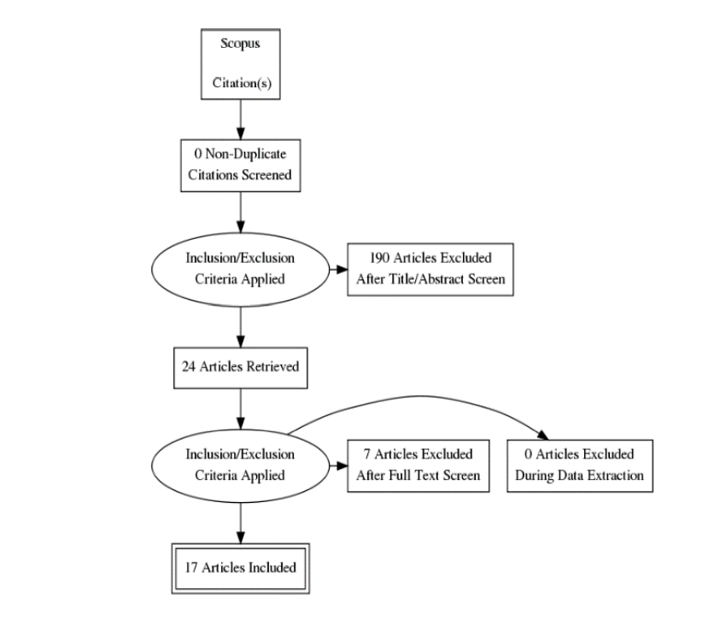

**(4)**

**Considering your results mention the main questions and problems that have been addressed to date and what are the major issues and debates about the topic ?**

Is Artificial Intelligence integrated Blockchain technology aiding to achieve the Sustainable Development Goal of Sustainable Cities and Communities (SDG11)?

Based on the research question, the research sub-questions are as follows:

What are the benefits of Blockchain and AI integration?

What are the Blockchain-AI challenges?

The fundamental idea of Blockchain is based on shared and distributed ledger technology, unlike traditional records maintained by a single bank or organization

Blockchain-AI has enabled the use of decentralized AI applications and algorithms which provide access to secure, trusted, shared platforms of logs, knowledge, and decisions

1- AI depends on the data to adapt, learn, and make decisions. Machine learning works better if data collected is from a reliable, trusted, and secure source. Blockchain act as a distributed ledger on which data is stored and transacted in a way that is cryptographically signed and validated.

2- Blockchain-AI have also enabled efficient automation by increasing the speed and efficiency of business processes for e.g. The AI model integrated into smart contracts can evaluate expired products, recall the products, and execute transactions automatically by reordering products, making payments, selecting the most sustainable shipping methods, and restocking of stocks by following a set threshold set on smart contract

3- The Blockchain-AI energy system has been adopted by Brooklyn Microgrid which uses Ethereum smart contracts and the Byzantine Fault tolerance consensus method to enable consumers to sell their electricity directly to their neighbors

**(5)**

**Draft 2-3 objectives for your thesis considering articles screened. ?**

1. Blockchain has the potential to assist the government in the governance of smart cities. The government can use Blockchain technology to record income, expenses, and government contracts on the Blockchain which will increase transparency and reduce corruption. The Blockchain can also be leveraged in the voting process by using smart contracts. The voter can cast vote once and this can be traced back to the Blockchain this will reduce the manipulation in the voting process and enhance transparency. Adding to that, Blockchain can provide a platform to centralize citizens identity in one place for instance the national identity, passport, and birth and death certificates of an individual can be linked to the Blockchain, and this will reduce the identity fraud
2. Future developments are currently focused on reducing the cost of transactions for blockchain networks. It is predicted that substantial business disruption will result from a drop in transaction costs above specific threshold values. The disruption is anticipated to take the shape of abrupt, dramatic, difficult-to-predict aggregations and dis-aggregations of current business models.
3. In the energy sector Blockchain technology has the potential to eliminate energy retailers from the energy sector. The services offered by a retailer such as billing and metering electricity consumption can be replaced by Blockchain technology, The substitution of retailers with Blockchain can result in reduced electricity bills by up to 40%, and by connecting users to the energy grid the Ethereum Blockchain enables users to buy electricity at the cost they are willing to pay this will result in a stable supply of electricity and at a lower cost. Moreover, the Blockchain can enable peer-to-peer energy trading between users as excess energy can be traded between participants reducing the control of central authorities such as wholesale retailers